Meet Etiquette for Gym Meets
The following reminders are for gymnasts and parents. Please read carefully!

Parents & Gymnasts
- Be friendly and use good sportsmanship. While in the stands, you represent Excite! and what we stand for—please keep all conversations positive and encouraging. Refrain from talking about other programs, athletes, or coaches from other gyms.
- Be aware of your surroundings. When going to the restroom or concession stand, pay attention to what’s happening in the meet and watch for parents recording their gymnasts. If music is playing on the floor, please wait until it finishes before moving. Walk behind the stands when possible, and stay low if you must pass in front of spectators.
- Gymnasts should stay focused throughout the meet. There should be no interaction with family, relatives, or friends from other gyms until after awards.
  - We know it’s tempting to go talk to parents, friends, or grandparents in the stands—and that’s encouraged before and after the meet! During the meet, however, gymnasts should remain focused on their coach, routines, and supporting teammates.
- Parents should never contact the host gym for meet information. All questions should be directed to gymnastics@excitegym.com, and we’ll provide the details you need.

Parents

WE DO:
- Wear red or Excite! shirts to show team spirit!
- Cheer loudly and proudly for our athletes!
- Reach out to coaches for any important or necessary communication.
- Arrive on time and meet-ready.

WE DON’T:
- Enter the competition area. This area will be roped off or clearly marked. This USAG safety rule ensures that only trained, background-checked personnel are inside the competition area.
- Approach the rope or barricade to talk to athletes or coaches during the meet.
- Use flash photography. This USAG rule protects the safety of competing gymnasts.

Gymnasts
- Check out with your coaches before leaving the meet.
  - A coach must release you directly to your parent or guardian before you may leave.
  - Gymnasts will not be released until after all awards have been given out, unless prior arrangements were made by emailing gymnastics@excitegym.com about a scheduling conflict.
- Stay off all equipment in the host gym unless instructed otherwise by your coach.
- During competition, gymnasts should remain seated quietly with their coach to show respect for those competing.
- Awards attire: Warm-ups must be worn during awards. This includes your meet leotard, meet capris, and jacket (zipped up), with no shoes.

What to Bring
- Excite! Backpack: All belongings must fit inside your Excite! backpack. Larger items (coats, boots, etc.) should stay with your adult in the stands.
- Water bottle: Must have a secure lid and fit in the backpack. (No Stanleys with straws—sorry, girls!)
- Easy, healthy snack and drink for during the meet.
- Socks: Some venues can be cold or have concrete floors. Please bring plain white or black no-show socks to keep warm between events.

How to Look
- Hair: Must be pulled up and completely out of the gymnast’s face for the entire meet. Use bobby pins, clips, hair spray, gel, and anything else needed to secure the style.
  - Choose a hairstyle that won’t interfere with your routines. (For example, some buns may affect backward rolls or back extension rolls.)
  - Approved hairstyles:
    - Ballerina bun (sock bun)
    - High, tight ponytail (braided, straight, or curled)
    - Space buns (must be tight and secure)
    - “College bun” (Platinum and Optional level athletes only)
    - Ask your coach for approval for any other hairstyles.
  - See pictures below for examples!
- Meet Uniform (Arrival Attire):
  - Meet leotard
  - Red meet scrunchie
  - Black leggings
  - Excite! warm-up jacket
  - Easy-on/off shoes (for restroom breaks)
  - Excite! backpack
  - Undergarments: Should not be visible. Underwear should be skin-toned or match the leotard color. Sports bras must have clear straps to remain discreet under the mesh shoulders and cut of the meet leotard.

Meet Leotard Washing Instructions
- Wash each garment separately.
- Turn inside out before washing.
- Use mild liquid detergent and gently hand wash in cold water. Rinse immediately.
- Do not soak.
- Hang to dry.
- Do not use fabric softeners, dry clean, or iron.

Meet Hair Examples
- YES:
- Braided or spider web into a pony tail or bun:

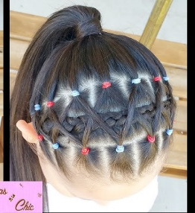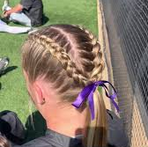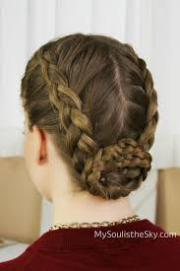
- Ballerina Bun: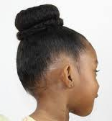 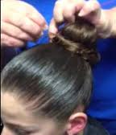
- Space Buns: 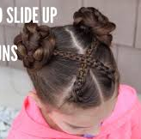 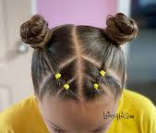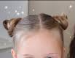
- “College Bun” This option is allowed for Platinum and Optional level athletes only!: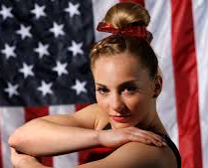 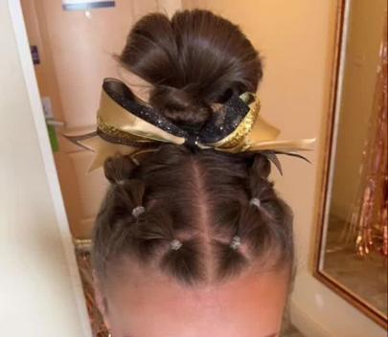

- *NO:
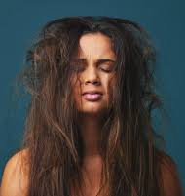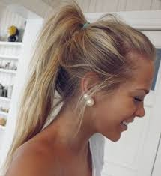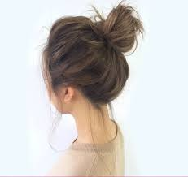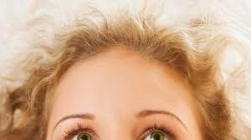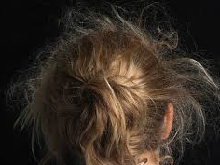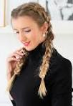

Remember:
These guidelines are in place to ensure the safety, professionalism, and success of our athletes!
If you ever have questions, please reach out to gymnastics@excitegym.com.

